|  |
| --- |
| NSW Traffic Penalty Data Search Executive Summary |
| Nikkelas Raines, Taiki Matehe2810ICT Software TechnologiesOctober 8, 2023 |

# Abstract

The data showed that there was an increase in penalties towards the end of the year, especially with mobile phone usage. The average cost of the penalties over the year was also shown to be higher the later on in the year, meaning that due to the holidays, people were more active driving around and the fine costs were increased.

# Introduction

The purpose of this report is to display the functionality of the program and explain how the data is shown. The data range covered is 01/01/2014 to 01/01/2015.  
The analysis tasks performed includes 3 graphs and 4 data display tasks.  
The graphs display the mobile phone usage over time, distribution of cases in each offense  
code and the average penalty case costs over time. The first data display task is the keyword search that displays the data that has the keyword within the row, the next is the video data task which displays all data that has been captured by a camera. The third task is the date search which displays all data within 2 dates. The final tasks is a reset search toggle which either allows the data to reset between tasks or use the last edited data which allows for searching for a keyword within a timeframe.

# **Analysis 1 <Display data of all penalty cases within a selected period >**

Half way through the data provided. Search shows all penalty cases within a selected period (01/01/2014 – 01/01/2015).

# **Analysis 2 < Toggle Data frame search reset>**

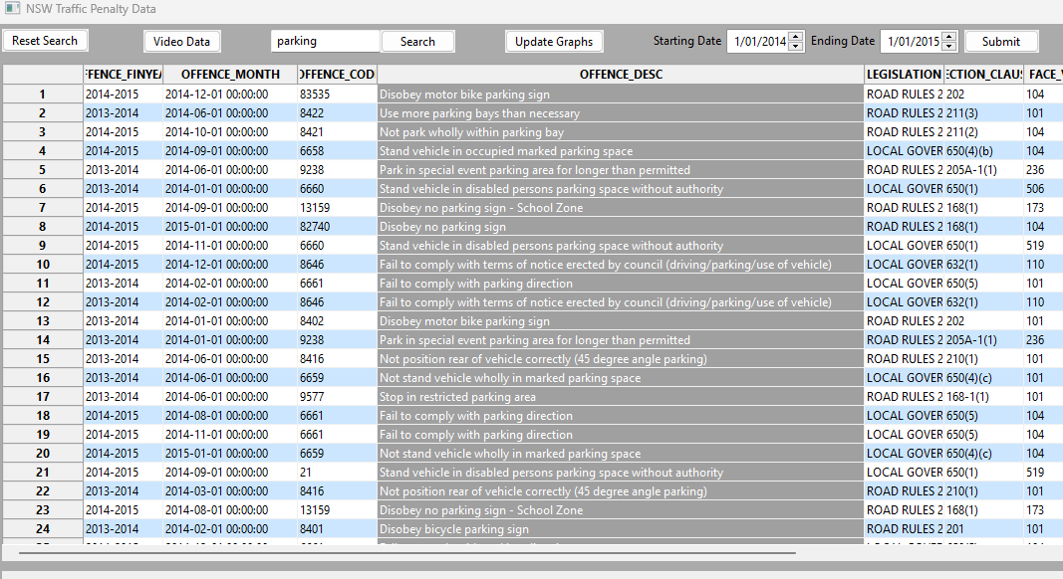

Image above shows the reset toggle off. Displays data within the selected period and with the given keyword (01/01/2014 – 01/01/2015, ‘parking’).

Image above shows reset toggle on. Displays data only with given keyword (‘parking’).

# **Analysis 3 <Retrieves all cases captures by radar or camera based on offence description>**

Image above shows search of all cases detected with a camera. Displays data with the description ‘Camera Detected’. The ‘Video Data’ button is the input.

# **Analysis 4 <Display data of all penalty cases with a keyword specified>**

Image above shows searching for the word tree. Displays all data in the description column containing the word ‘tree’, non-case sensitive. First row contains the keyword tree in the word ‘street’.

# **Analysis 5 < Display a chart that shows distribution of cases in each offense code >**

Most cases are around 20 while one jumps to 75 which means its over 50 as there is a limit to not cause the other bars to be too small.

# **Analysis 6 < Display a chart that shows mobile phone usage trend over time >**

Mobile Phone usage rises during the end of the year.

# **Analysis 7 < Display a chart that shows average penalty case cost over time >**

The Average fine amount slowly raises during the year and jumps during the last month.